Stat 112
Fall 24 – Mahtash Esfandiari and Jiale Han
Assessment

Question Possible points Actual points

One 40 __________

Two 40 __________

Three 20 __________

Total 100 ___________

This is a closed book exam and you can have access to a cheat sheet written on front and back. You are not supposed to use the Internet or your phone.
Any misconduct will be reported to the Dean’s office and it will be dealt with based on university regulations.

Question one. Given table one, table two, and plot one, answer questions a to g. (40 points)
Definition of variables (data is about UCLA undergrads)
academicenvp = confidence in academic confidence
classcomfort= uncomfortable, somewhat comfortable, comfortable, very comfortable
welcomingenvp = feeling welcome
- Interpret the coefficient for very comfortable (bolded) within context. 6 points
Keeping all else constant… (enough to say it once; if they never say it (-1)
On average (-1) the students who find our classroom climate very comfortable score 13.88 points higher on academic confidence that those who find our classroom climate uncomfortable.No context (-2)
- Interpret the coefficient of welcoming (bolded) within context. 6 Points
If we increase the feeling of being welcome by one point, on average, academic confidence increases by 0.30 units.
- State the question underlying plot one within context. 6 points
Does the effect of class climate on academic confidence vary by feeling of comfort?
OR
Does the effect of climate comfort on academic confidence vary by classroom comfort?
- Interpret plot one within context– 6 points
The effect of climate comfort on academic confidence does not very with class comfort in all four conditions of class climate (uncomfortable, somewhat comfortable, comfortable, and very comfortable) as feeling of comfort in our climate increases so does academic confidence.
e. Interpret R-squared within context. 6 points
- 23.78% of the variance in academic confidence is explained by class comfort and perception of being welcome in our environment.
- Cannot say predictors in the model because not all are significant.
- Saying significant predictors in the model gets partial credit. (-2)

f. In multiple linear regression models they generally report MSE. What is MSE a measure of? 5 points
Either explanation that is complete and thorough gets full credit.
Conceptual explanation
MSE or mean square error is the variance of error and it is a measure of error in the model at hand. If you are comparing multiple models, the one with the lower MSE is the better model. It is a measure of the proportion of variance in the outcome variable that we cannot explain.
Mathematically:
MSE or $S_{e}^{2}$ = $\frac{\sum_{i=1}^{N}{e_{i}^{2}}}{N-k-1}$
$e_{i}=Y_{i}-Y^{^}$ (residual equals actual score minus predicted score)
(1-R^2) = RSS/TSS
RSS is the sum of square of residuals. The higher the RSS, the lower (1-R^2) or the proportion of variance we cannot explain.
g. If you wanted to find MSE for the linear model, how would you do it? 5 points
MSE or $S_{e}^{2}$ = $\frac{\sum_{i=1}^{N}{e_{i}^{2}}}{N-k-1}$
(1-R^2) = RSS/TSS
The output given does not give us all the information we need to calculate MSE

Outputs for question one
Relevant Model
> model<-lm(academicenvp~classcomfort*welcomingenvp)
> summary(model)
Table one : classcomfort
uncomfortable somewhat comfortable very comfortable
380 1172 2913 910
Table two: Summary table resulting from the model
Coefficient | coefficient | Standard error | t -value | Pr(>|t|
Intercept | 38.70 | 1.63 | 23.74 | 0.000
Very comfortable | 13.88 | 3.81 | 3.64 | 0.000
comfortable | -3.78 | 3.26 | -1.16 | 0.174
Somewhat comfortable | 3.52 | 2.56 | 1.36 | 0.174
welcomingenvp | 0.30 | 0.02 | 13.02 | 0.000
very comfortable*welcoming | -0.01 | 0.05 | -0.23 | 0.816
Comfortable*welcoming | 0.07 | 0.07 | 1.50 | 0.133
Somewhat*welcomingp | -0.05 | 0.05 | -1.38 | 0.167
Residual standard error: 13.87 on 1974 degrees of freedom
Multiple R-squared: 0.2783, Adjusted R-squared: 0.2758
F-statistic: 108.8 on 7 and 1974 DF, p-value: < 2.2e-16

Plot one: Interaction effect between class comfort and feeling welcome

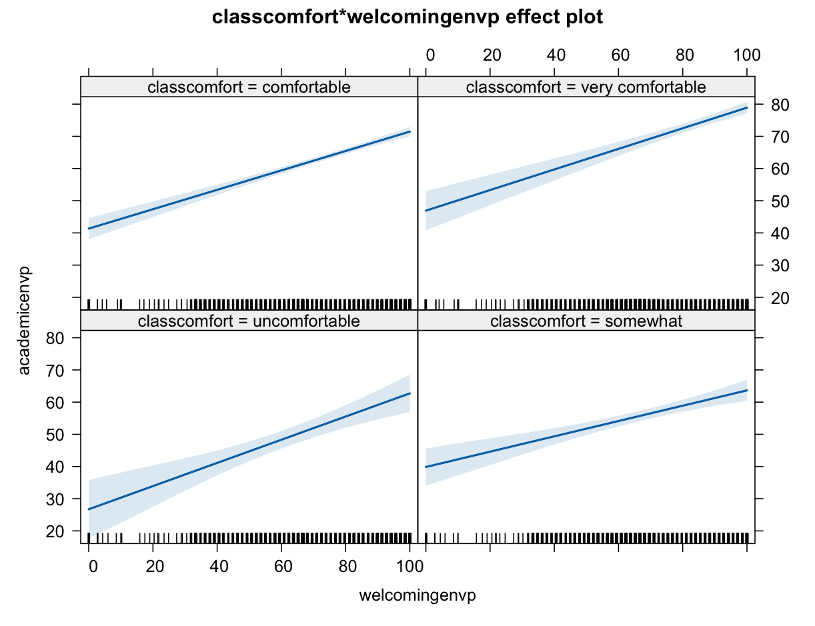

Question two. Given m0, m, table one, table two, table three, plot one, plot two, answer the following questions. 40 points

Variables of the study
Divrespectp = feeling of respect for diversity (numerical)
Excluengligh = feeling of exclusion on the basis of spoken English (No, Yes)
Exclurace = feeling of exclusion on the basis of spoken race (No, Yes)
Exclucountry = feeling of exclusion based on the country of origin (No, Yes)

> m0<-glm(exclurace~1,family="binomial")
> summary(m0)
Null deviance: 1267.4 on 938 degrees of freedom
Residual deviance: 1267.4 on 938 degrees of freedom
AIC: 1269.4

m1<-glm(exclurace~divrespectp+excluenglish*exclucountry,family="binomial")
Table one – output resulting from m1
> m1<-glm(exclurace~divrespectp+excluenglish*exclucountry,family="binomial")
> summary(m1)

Coefficients:
Estimate Std. Error z value Pr(>|z|)
(Intercept) 0.48185 0.30308 1.590 0.111866
divrespectp -0.01802 0.00399 -4.517 6.27e-06 ***
excluenglish1 1.22049 0.21272 5.738 9.60e-09 ***
exclucountry1 0.93199 0.25404 3.669 0.000244 ***
excluenglish1:exclucountry1 -0.06255 0.41573 -0.150 0.880396
---
Signif. codes: 0 ‘***’ 0.001 ‘**’ 0.01 ‘*’ 0.05 ‘.’ 0.1 ‘ ’ 1
Null deviance: 1267.4 on 938 degrees of freedom
Residual deviance: 1130.3 on 934 degrees of freedom

Question 2.1
Using m0 and m1, if you were the TA for this class, how would you explain the difference between null residual and model residual. 6 points.

m0 is intercept only model. Null residual is the residual for a model with not predictors.
m1 is a model with four predictors, three of which are statistically significant which cause the null residual to decrease. Model residual is the residual of m2. But, notice that null residual does not change no matter how many significant predictors are in the model.

Question 2.2 Given m1:
- What is the research question underlying m1? Please be within context. 5 points

Can we predict the odds of feeling exclusion on the basis of race from perception of respect for diversity (A), exclusion on the basis of spoken English (B) , country of origin (C), and the combined effect/interaction of B and C.

- Interpret the 95% confidence interval of the odds for exclusion on the basis of spoken English WITHIN CONTEXT. (see table two in next page – it is bolded) – 5 points

We are 95% confident that, the students who feel excluded on the basis of spoken English, the odds of feeling exclusion on the basis of race increases from 2.24 to 5.17.

Question 2.3

- If you were to draw the plot of odds, which interval (see table two in next page) would you expect not to include one and why? 5 points

We would expect the interaction effect not to include the interval because first of all the p-value is higher than 0.05 (0.88) and the interval includes one (0.41 – 2.14).

- Interpret 0.84 within context. 5 points
> exp( -0.01802*10) – notice that -0.01802 is from table one in previous page (it is bolded)
[1] 0.84

Keeping all else constant, if we increase respect for diversity by ten points, the odds of feeling exclusion on the basis of race decrease 16%.

Table two. Table of odds, 95% confidence interval for odds, and P-value for the coefficient of m1
Predictor | odd | 95% CI for odd | p-value
Respect for diversity | 0.98 | 0.97-0.99 | 0.000
Exclusion on the basis of spoken English (Yes) | 3.39 | 2.24-5.17 | 0.000
Exclusion on the basis of country of origin (Yes) | 2.54 | 1.54 -4.19 | 0.000
Interaction between exclusion based on spoken language and country of origin | 0.94 | 0.41-2.14 | 0.880

Table three: The actual and the predicted (based on m1) number of UCLA students who felt exclusion on the basis of race.
Predicted value | Actual frequency of feeling excluded on the basis of race
Predicted value | No | Yes
No | 477 | 213
Yes | 82 | 167

Question 2.4 Given table three
- Compute accuracy of the model. Show your calculations. Find the final answer. 7 points

(477 + 167)/(477+167+213+92) = 0.6786

- Did the model do better with sensitivity or specificity? Choose one. 7 points

Sensitivity ________

Specificity _______
Explain why?

It did better with specificity because the predicted and actual values for those who do not feel excluded on the basis of race are larger than predicted and actual values who those who feel excluded (no, no = 477, yes, yes = 167)

Question three: Given the following plot one, output one, and output two, answer the following questions. 20 points

Variables in the study:
Academicenvp = academic confidence (numerical) – This is the outcome
Friendlyenvp = friendliness of our environment (numerical)
Overallclimatep = overall UCLA climate (numerical)
Prejudicenvp = feeling of prejudice (numerical)
Firtgen = (yes,no)
gpa(categorical – 4 levels)
lowfamilyincomeindicator (Yes,no)

Plot one
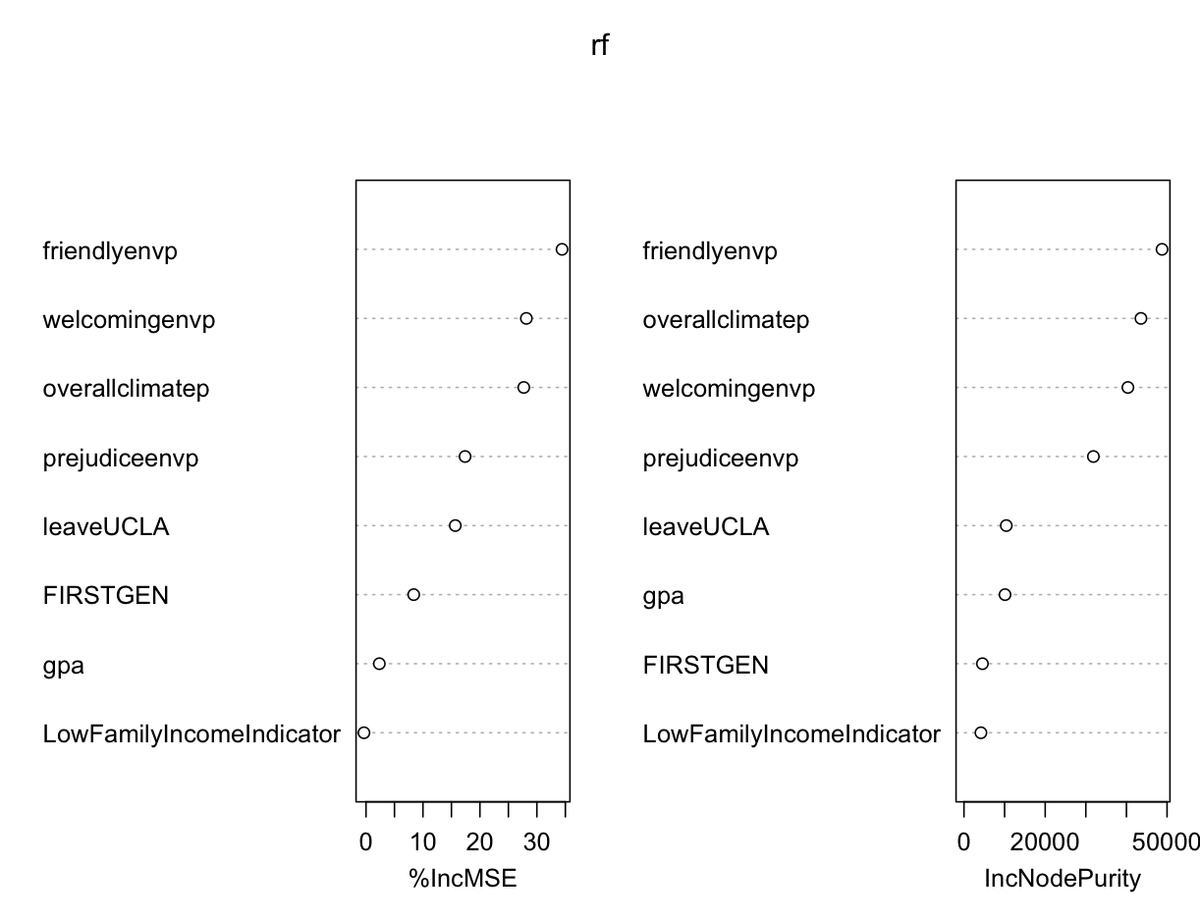
Model one
> model one<-lm(academicenvp~friendlyenvp+welcomingenvp+overallclimatep+prejudiceenvp+leaveUCLA+FIRSTGEN+gpa+LowFamilyIncomeIndicator)
> summary(m1)
Coefficients:
Estimate Std. Error t value Pr(>|t|)
(Intercept) 26.26467 4.50794 5.826 6.97e-09 ***
friendlyenvp 0.18798 0.03772 4.983 7.01e-07 ***
welcomingenvp 0.14510 0.02203 6.586 6.31e-11 ***
overallclimatep 0.24984 0.03106 8.044 1.80e-15 ***
prejudiceenvp -0.13607 0.03403 -3.999 6.68e-05 ***
leaveUCLAyes -5.99603 1.01437 -5.911 4.23e-09 ***
FIRSTGENyes 1.49963 0.80724 1.858 0.0634 .
gpa3 - 3.49 0.81395 1.01130 0.805 0.4210
gpa3.5 and above 1.26818 1.00601 1.261 0.2077
gpaBelow 2.49 -1.81451 1.65066 -1.099 0.2718
LowFamilyIncomeIndicatorNot Low Income -1.76750 0.77539 -2.279 0.0228 *
Residual standard error: 13 on 1449 degrees of freedom
Multiple R-squared: 0.3808, Adjusted R-squared: 0.3765

Model two
> modeltwo<-lm(academicenvp~friendlyenvp+welcomingenvp+overallclimatep+prejudiceenvp+leaveUCLA)
> summary(m6)
Coefficients:
Estimate Std. Error t value Pr(>|t|)
(Intercept) 26.31595 4.44605 5.919 4.04e-09 ***
friendlyenvp 0.18508 0.03783 4.893 1.11e-06 ***
welcomingenvp 0.14032 0.02199 6.381 2.35e-10 ***
overallclimatep 0.25485 0.03111 8.191 5.62e-16 ***
prejudiceenvp -0.12879 0.03405 -3.783 0.000162 ***
leaveUCLAyes -6.28320 1.00773 -6.235 5.91e-10 ***

Residual standard error: 13.05 on 1454 degrees of freedom
Multiple R-squared: 0.3739, Adjusted R-squared: 0.3717

- What does plot one show? 5 points

The variable importance plot shows the relative importance of predictors that could be included in the model.

- What do you conclude from it? 5 points

The first five seem to be the most important as they create the highest decrease in MSE

- If you were the statistician on this project, would you recommend model one or model two? Choose one. 10 points
Model one ______ Model two ______

I recommend model two
Give two reasons why you choose one model one over model two or model two over model one. (Either of the following reasons is fine)

- Fewer predictors (More parsimonious model
- Same R^2 as the complicated model.
- Model one is an example of overfitting; including variables that do not make the model stronger

